**Title: Fluorescence lifetime imaging detects long-lifetime signal associated with reduced pyocyanin at the surface of *P. aeruginosa* biofilms and in cross-feeding conditions**

T. Gallagher*, S.W. Leemans*, A. Dvornikov, K. Perinbam, J. Fong, C. Kim, J. Kapcia, M. Kagawa, A. Grosvirt-Dramen, A. Hochbaum, M. Digman, E. Gratton, A. Siryaporn, K. Whiteson

* T.G. and S.W.L. contributed equally

Journal: ACS Infectious Disease (3,000 words, 5 figures max, abstract 150 words)

Current word count: 2953

**Abstract:**

Understanding bacterial physiology in real-world environments requires non-invasive approaches and is a challenging yet necessary endeavor to effectively treat infectious disease. Bacteria evolve strategies to tolerate chemical gradients associated with infections. For example, the opportunistic pathogen *Pseudomonas aeruginosa* utilizes the redox-active metabolite, pyocyanin, as an alternative electron acceptor in low-oxygen. The reduced form of pyocyanin, in addition to other metabolites produced by *P. aeruginosa,* are fluorescent. The DIVER (Deep Imaging Via Enhanced Recovery), a custom-made instrument originally designed for deep tissue imaging, was used to image *P. aeruginosa* auto-fluorescence and the fluorescence lifetime throughout biofilms. Using the DIVER, a long lifetime signal associated with the reduced form of pyocyanin was detected at the surface of *P. aeruginosa* biofilms, where growth was dense and oxygen consumption was likely high. Additionally, *P. aeruginosa* cultures produced the longer fluorescence lifetime signal in the presence offermentation metabolites from *Rothia mucilaginosa,* which co-colonizes infected airways with *P. aeruginosa*.

**INTRODUCTION**

To colonize an infection site, bacteria adapt to the chemical conditions associated with infected tissue, including oxygen depletion (1, 2). Hypoxic conditions, commonly found in wounds and the airways of persons with cystic fibrosis (CF), pose a challenge to opportunistic pathogens, such as *Pseudomonas aeruginosa.*

*P. aeruginosa* survives in low-oxygen environments through anaerobic respiration via denitrification (3, 4) and secreting phenazines (5–7), which are colorful, electron-recycling molecules (6–10). Pyocyanin, the final product in the phenazine pathway, has the highest affinity for oxygen (9), and when fully oxidized, can be reduced by *P. aeruginosa* cells as they metabolize glucose into acetate (7). In addition to low oxygen, *P. aeruginosa* can produce pyocyanin when triggered by quorum sensing, or in the presence of other microorganisms, e.g., when exposed to the fermentation products lactic acid and butanediol (11, 12) produced by co-colonizing *Rothia mucilaginosa* (13, 14).

Pyocyanin is a non-fluorescent, blue-pigmented molecule in its oxidized form (15, 16). However, the reduced form of pyocyanin is fluorescent, and the emission spectrum overlaps with other fluorophores including NADH and pyoverdine. The overlapping spectra makes it challenging to resolve the fluorescent signal of pycoyanin using single-channel fluorescent microscopy (17).

Hyperspectral imaging is an approach used to unmix multiple fluorophores (17). However, the limited imaging depths of commercial microscopes poses challenges to spatially resolving signals throughout naturally formed oxygen gradients. The DIVER (Deep Imaging Via Enhanced Recovery) (18, 19) is a custom-made microscope for deep tissue imaging that measures fluorescence intensity and lifetime. The fluorescence lifetime refers to the exponential decay of the fluorescent intensity and can be used to identify the composition of multiple fluorophores contributing to a signal. For example, fluorescence lifetime imaging microscopy (FLIM) of NADH is often employed to investigate cellular respiratory state, because the lifetime of NADH shifts depending on local conditions. The lifetime of free NADH is short (0.4 ns), while enzyme-bound NADH exhibits lifetime values ranging from 1.7 to 9 ns (20–22).

FLIM data can be transformed and represented on phasors, a fit-free approach to analyze fluorescence lifetime data (23, 24) (**Fig. 1**). Fourier transformation of exponential decay traces yields modulation (M) and phase (φ) values for a given harmonic. The sine and cosine coefficients of the transform form the y- and x-axes of the lifetime phasor (23). Longer lifetimes are near the origin (G=0, S=0) of the phasor, while shorter lifetimes are near the right-hand corner (G=0, S=1). Pure species with single exponential decays are located on the universal circle of the phasor (**Fig. 1A**). Changes in the FLIM phasor position indicate a shift in the relative abundance of fluorophores for samples containing multiple fluorophores. For example, when bound to enzymes, NADH displays a right-shifted signal on the phasor (or longer lifetime) relative to free NADH (**Fig. 1B**). Another powerful feature of the phasor is the ability to overlay phasor analyses onto images, allowing for the visualization of spatially-dependent lifetime signals (**Fig. 1C**).

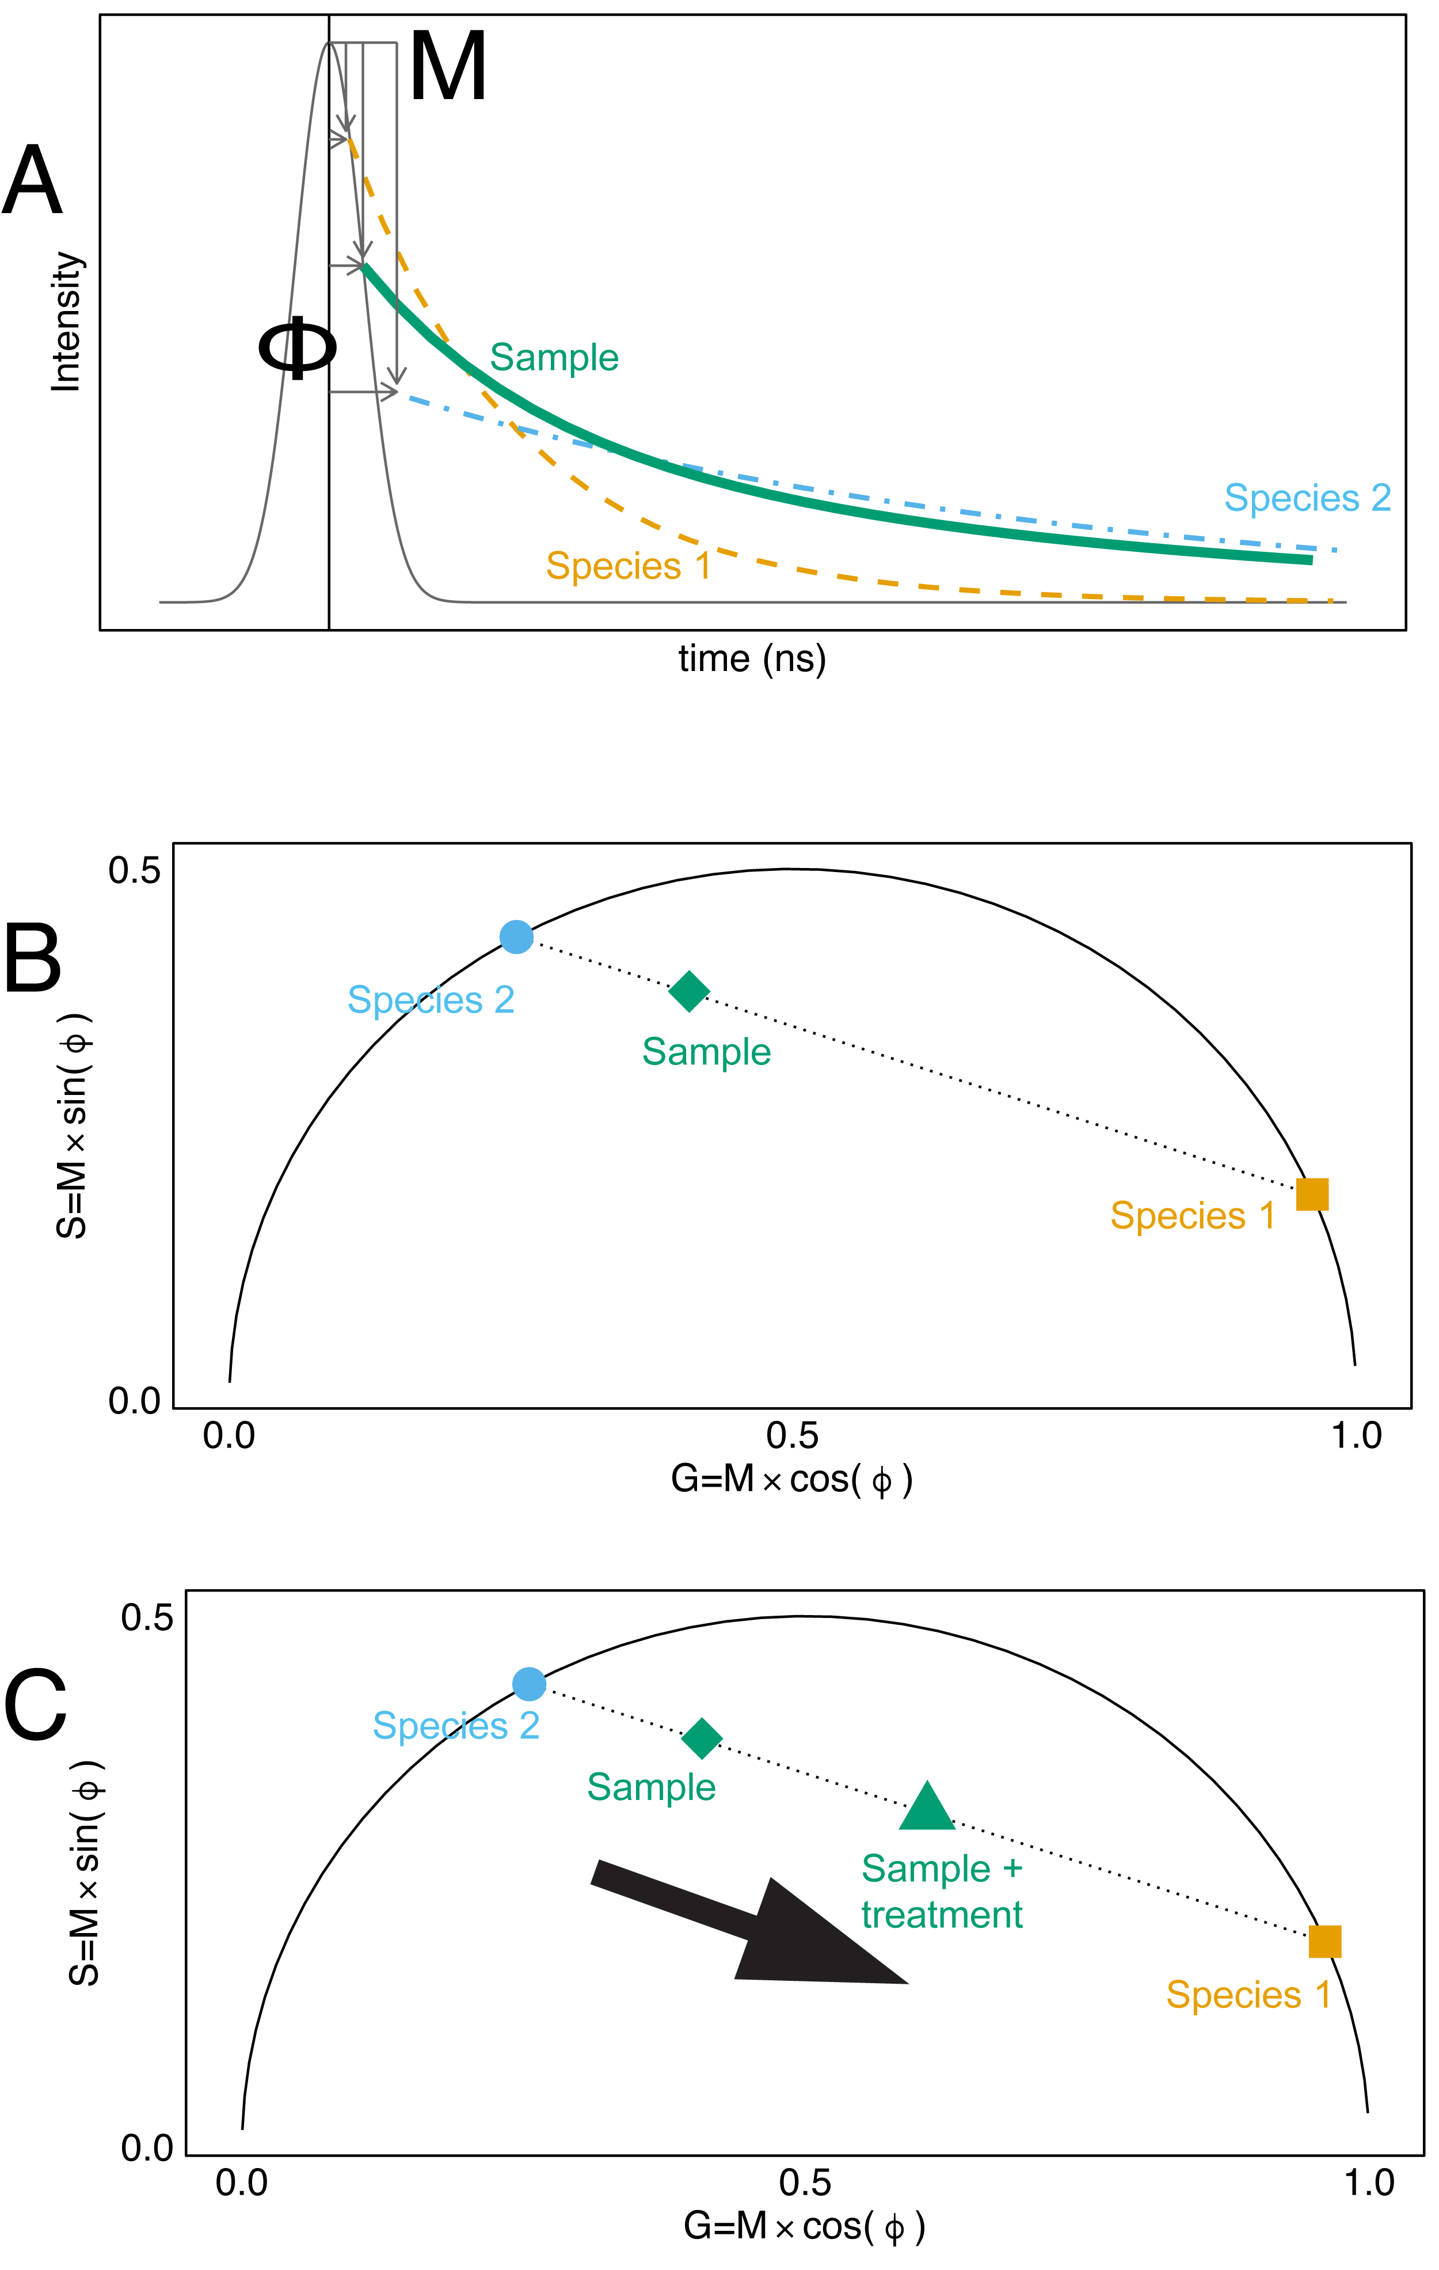

**Figure 1:** A simplified representation of the transformation of fluorescence exponential decays into the fluorescence lifetime phasor. **(A)** A Fourier transform is used to calculate the modulation (M) and phase shift (φ) relative to the laser pulse excitation source. M and φ are represented graphically for two pure fluorophores (orange dash line, blue dash-dot line) and a sample containing a mix of the two species (green solid line) (1). **(B)** The phasor G and S coordinates are the cosine and sine components of the Fourier transforms. Species closer to the origin of the phasor have long lifetimes, whereas species on the right corner of the phasor have short lifetimes (1). **(C)** Shifts in the phasor coordinates of samples can be indicative of changes in the relative abundance of fluorescence species. For example, in a sample containing two fluorescent species, shifts in the phasor position are associated with shifts in the abundance of the two fluorescent species (1, 2).

Here, the DIVER was used to characterize the fluorescence lifetime of *P. aeruginosa* biofilms in infection-relevant conditions, including throughout biofilms and in the presence of *Rothia*-derived metabolites.

**RESULTS:**

**Spectral characterization of *P. aeruginosa* fluorophores.**

The 2-photon emission spectra of *P. aeruginosa* fluorophores were characterized with a hyperspectral imaging microscope (excitation = 740 nm, emission = 400-690 nm) (**Fig. S1, Fig. 2**). Pyocyanin and 1-hydroxyphenazine had broader spectra than previously published data (17), and chemically and electrochemically reduced pyocyanin had two peak wavelengths: 475 and 520 nm. In contrast, others found reduced pyocyanin had a single fluorescent peak around 475 nm (17). Worth noting, the fluorescent spectra of pyocyanin shifted depending on the reduction method (**Fig. S2, S3**). Specifically, with higher concentrations of reducing agent, the spectra shifted towards longer wavelengths (**Fig. S2**). These findings suggest the pyocyanin solutions consist of multiple fluorescent subspecies (**Fig. S3**).

**FLIM phasor characterization of *P. aeruginosa* fluorophores.**

Based on the spectral analyses (**Fig. 2, S1**), four of the eight fluorophores (NADH, reduced pyocyanin, 1-hydroxy-phenazine, and pyoverdine) can be captured by the FLIM acquisition parameters used in downstream experiments, which included a two-photon excitation of 740 nm and a blue emission filter (400-500 nm).



**Figure 2: Fluorescent spectra and lifetime phasor of some of the fluorescent metabolites produced by *P. aeruginosa***(two-photon excitation = 740 nm).

(**A**) Florescence emission spectra normalized by max peak intensity of fluorophores which emit in the 400-500 nm window (grey-shaded box). (**B**) Fluorescence lifetime phasor of fluorescent solutions, collected with a Schott BG-39 filter and NADH-targeted optical bandpass emission filter (400-500 nm). Points represent the phasor G and S coordinates from a fluorescence lifetime image, colored by the number of pixels. The large shapes represent the mean G and S values for each fluorescent solution. The mean G and S values for LDH NADH and OLS were determined from previously reported fluorescence lifetimes (3, 4). LDH = Lactate Dehydrogenase, OHPhz = 1-hydroxyphenazine, OLS = Oxidized Lipid Signal, PVD = pyoverdine, PYO = pyocyanin.

Fluorescence lifetime data can be represented on the phasor (**Fig. 1**) (23, 24). The FLIM phasor positions of solutions of free NADH, reduced 1-hydroxyphenazine, reduced pyocyanin, and pyoverdine are on the universal circle, suggesting the signals originate from a single exponential decay (**Fig. 2**). For reference, also depicted are the previously reported phasor coordinates of lactate dehydrogenase (LDH) bound NADH (25) and an oxidized lipid signal (OLS) (26). Notably, reduced pyocyanin had a long lifetime signal (mean G= 0.02, S= 0.1; lifetime >10 ns) with a distinct phasor position (**Fig. 2**). This long lifetime signal has only been identified in *P. aeruginosa* cultures and not in other microbial cultures, when excited at 740 nm and filtering for emission spectra ranging from 400-500 nm (**Fig. S4**) (27).

The lifetime of pyocyanin shifted with increasing TCEP concentrations (**Fig. S2A**). Pyocyanin was nearly on the universal circle when mixed with a 1:1 ratio of TCEP (**Fig. 2, S2B**). Taken together, the spectral and phasor data suggest chemically and electrochemically reduced pyocyanin solutions contain multiple subspecies. However, the FLIM acquisition settings used (400-500 nm emission filter) capture the reduced form.

**Longer fluorescence lifetimes at the surface of *P. aeruginosa* biofilms**

The fluorescence intensity and lifetime were acquired throughout different depths of five-day old *P. aeruginosa* biofilms grown in artificial sputum medium (ASM) or M9 succinate agar using a custom-made microscope at the Laboratory for Fluorescence Dynamics, the DIVER (18, 19, 28). Two strains of *P. aeruginosa* PA14were cultured: wildtype (WT) and a phenazine double mutant *P. aeruginosa* PA14 *∆phzA1-G1*/ *∆phzA2-G2* (∆*phz*)(29), which does not produce phenazines. Laser power was increased with deeper imaging in the sample to compensate for signal attenuation. The emitted fluorescence intensity was similar throughout the biofilm, suggesting effective excitation delivery (**Fig. S5**).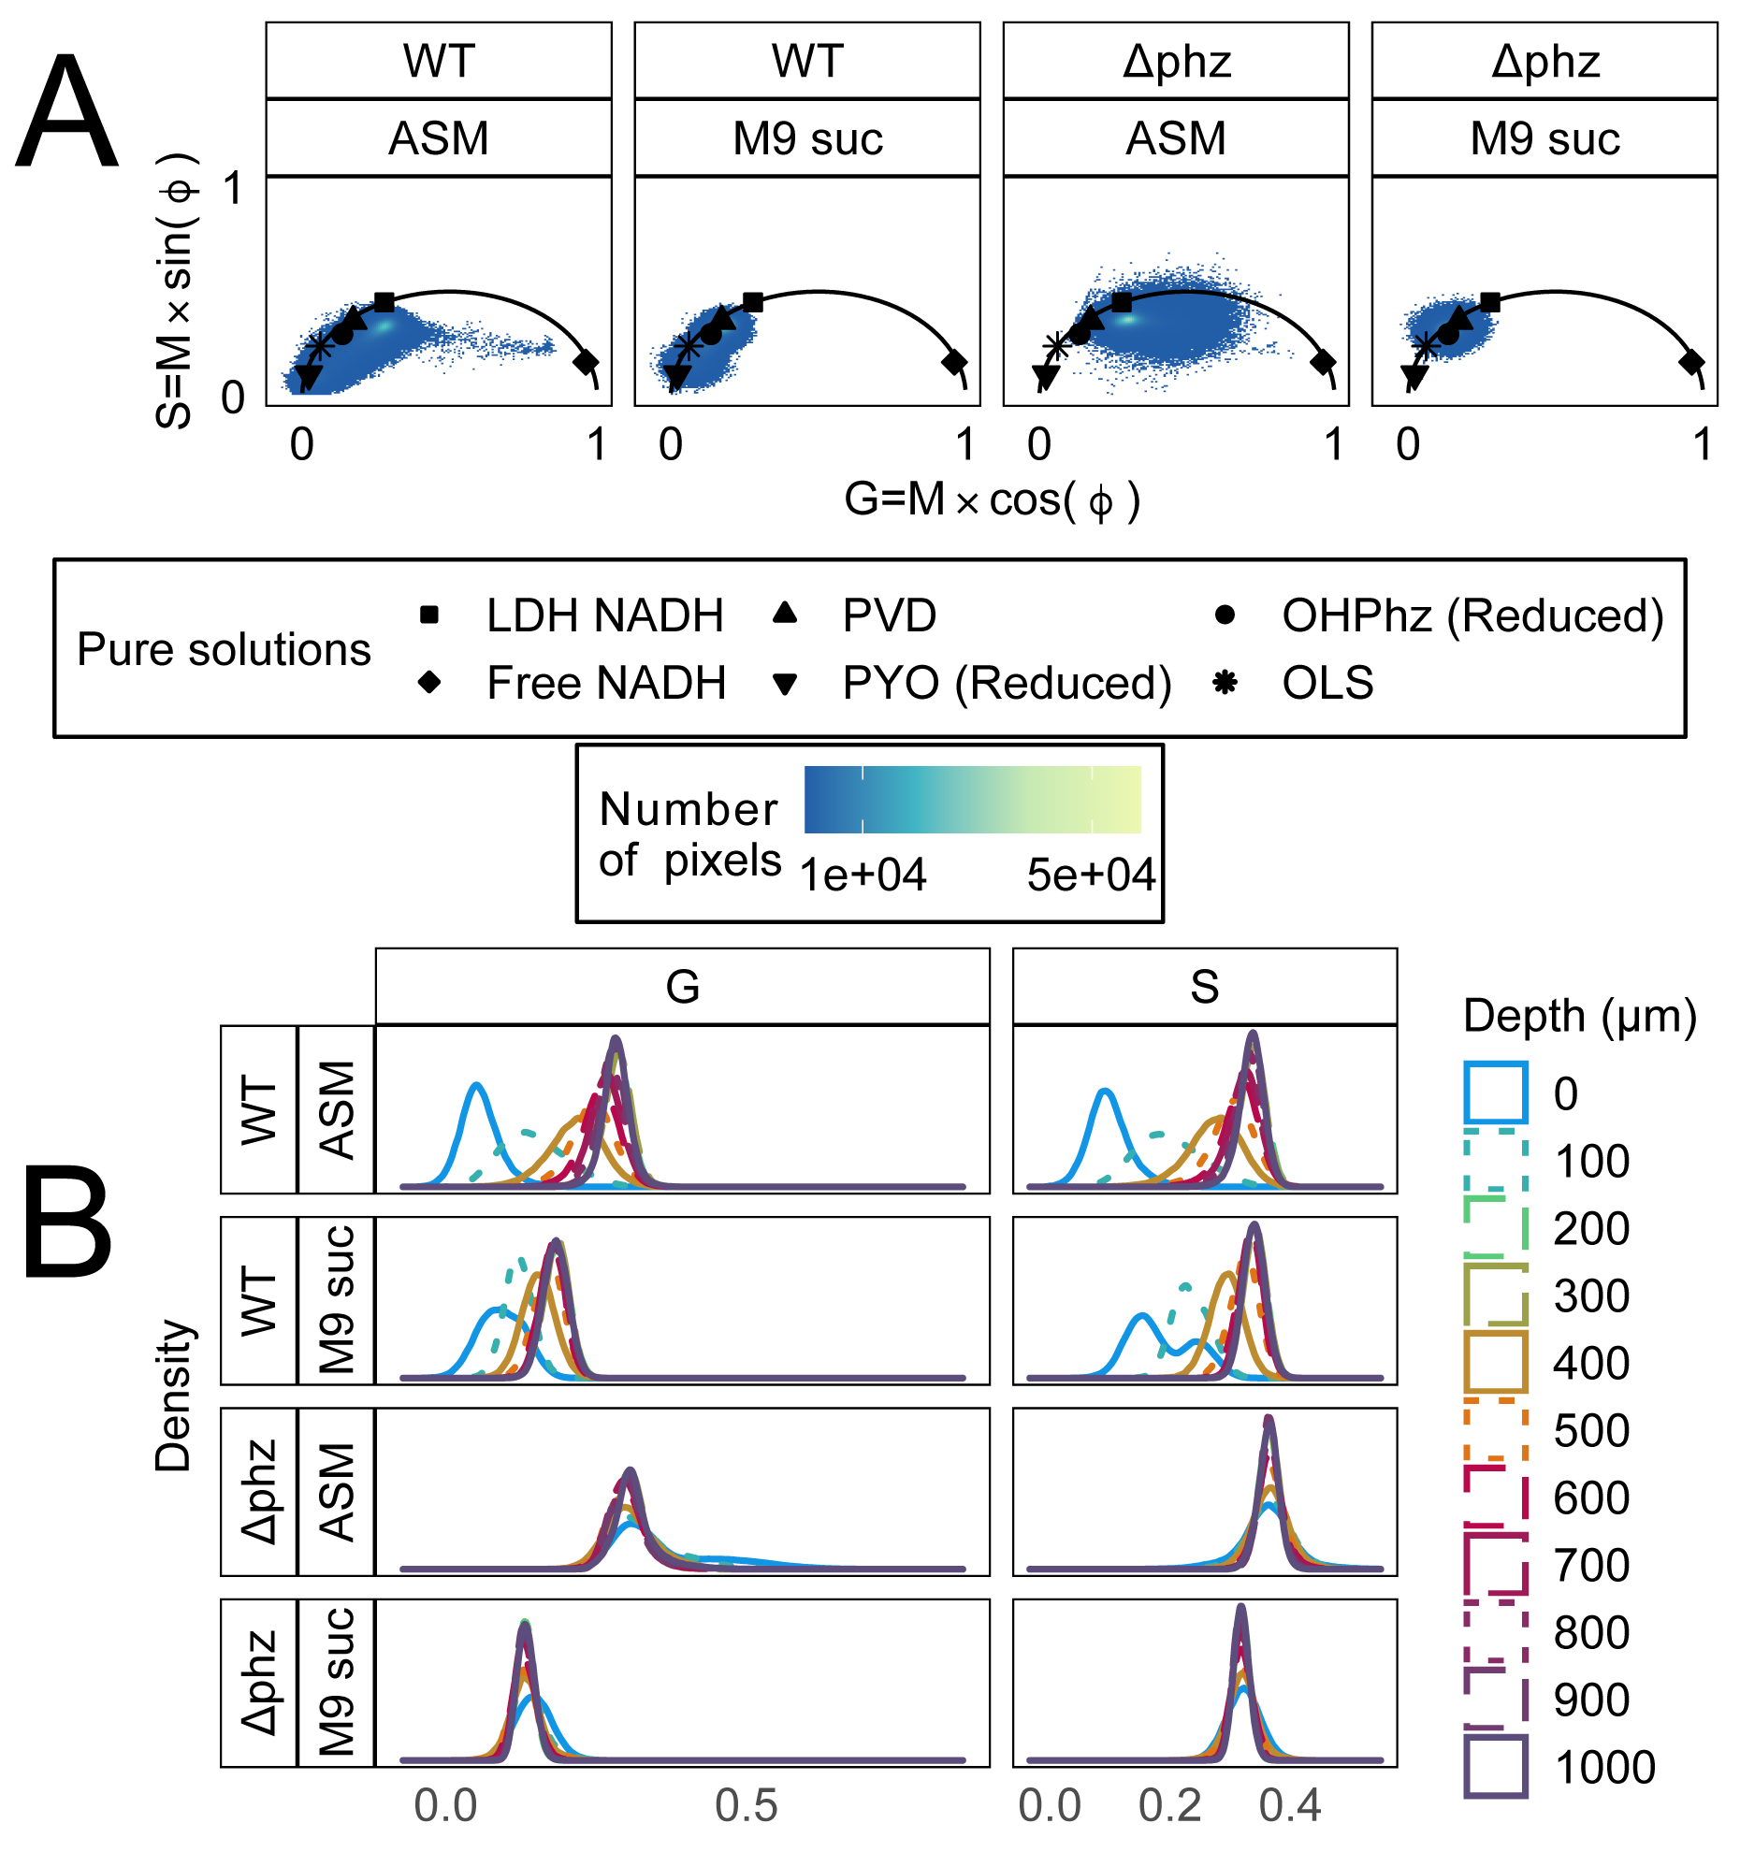 **Figure 3: Fluorescence lifetime at different depths of *P. aeruginosa* PA14 biofilms.** (**A**) Fluorescence lifetime phasor of *P. aeruginosa* PA14 WT and ∆phz strains grown in ASM or M9 succinate soft agar for 72h. Three replicates of biofilms were imaged every 100 µm from the biofilm surface (0 µm) to the bottom (1000 µm) (33 images per strain and media type, 132 images total). The scatter plot points are G and S values of pixels from fluorescence lifetime images, where the color indicates number of pixels at a given G,S coordinate. For reference, mean G and S values of fluorescent solutions from Figure 2 are displayed as black shapes. (**B**) One-dimensional distribution of phasor G and S values, where line type and color are indicative of biofilm depth (0 µm = biofilm surface). The G and S distributions from the surface of the WT biofilms were significantly shifted to the left of the *∆phz* biofilm surfaces in both media types (Wilcoxon rank sum test, p-value < 2.2e-16) *∆phz* = *P. aeruginosa* PA14 *∆phzA1-G1/∆phzA2-G2*; does not produce PYO or OHPhz. LDH = Lactate dehydrogenase, OHPhz = 1-hydroxyphenazine, OLS = Oxidized Lipid Signal, PVD = pyoverdine, PYO = pyocyanin, ASM = artificial sputum medium, suc = succinate.

The phasor position of cultures was distinct from uninoculated media (**Fig. S6**). Cell density decreased with biofilm depth (**Fig. 3**). The FLIM phasor signal of the WT strains shifted with biofilm depth in both ASM and M9 succinate (**Fig. 3, 4**). However, the depth-dependent lifetime shift was not observed in the *∆phz* cultures (**Fig. 3, 4**). The surface of the WT biofilm was dominated by a longer lifetime species, with G and S values shifted to the left of the *∆phz* strains (Wilcoxon rank sum test, p < 0.05 for both ASM and M9 suc comparisons). The fluorescence lifetime signals of the WT strain in both ASM and M9 media were similar to reduced pyocyanin.

Notably, the long lifetime signal associated with the WT cultures was prominent when a coverslip was placed on the biofilm samples. When imaged with an air objective, the lifetime signal of the biofilm with a coverslip was closer to reduced pyocyanin than that of the biofilm without a cover slip (**Fig. S7**).



**Figure 4: Fluorescence intensity and lifetime images at the surface and bottom of *P. aeruginosa* PA14 biofilms.** (**A**) Examples of auto-fluorescent intensity images of *P. aeruginosa* PA14 WT and *∆phz* strains grown in ASM or M9 succinate soft agar for 72h. Scale bar = 20 µm. (**B**) The fluorescence lifetime image at the surface and bottom of *P. aeruginosa* biofilms. In the image (**B**) and corresponding phasor (**C**), each pixel in the image is colored based on phasor position. For reference, mean G and S values of fluorescent solutions from Figure 2 are displayed as black shapes (**C**). The same color map was used for all lifetime images, where blue is indicative of a longer lifetime near the origin of the phasor (G=0, S=0) and orange is indicative of shorter lifetime near free NADH (lifetime = 0.4 ns; G=0.96=, S=0.19). ASM = artificial sputum medium, suc = succinate.

***P. aeruginosa* fluorescence lifetime shifts in the presence of *Rothia* metabolites**

To further investigate previous observations that *P. aeruginosa* increases pyocyanin production in the presence of microbial fermentation metabolites (11, 12), *P. aeruginosa* PaFLR01 was grown with supernatant from *Rothia mucilaginosa (*M9 suc + sup), in M9 media alone (M9 suc), or in ASM (the background media of the *Rothia* supernatant) (**Fig. 5**). The G and S distributions of *P. aeruginosa* grown in M9 suc + sup were significantly shifted to the left of the M9 alone and ASM cultures (Wilcoxon rank sum test, p < 2.2e-16, **Fig. 5A**).In other words, *P. aeruginosa*’s fluorescentlifetime shifted towards reduced pyocyanin in the presence of *Rothia-*derived metabolites (**Fig. 5A, 5C**).

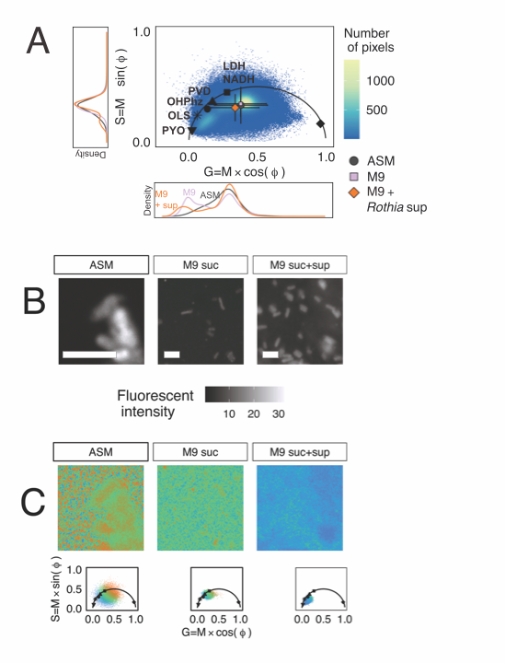

**Figure 5: *P. aeruginosa* PaFLR01** **fluorescence lifetime shifts when cross-fed *Rothia* supernatant.** (**A**) Fluorescence lifetime phasor of *P. aeruginosa* PaFLR01 grown in three media types under hypoxic conditions for 72h. Scatter plot points are G and S coordinates of pixels from fluorescence lifetime images of PaFLR01 grown in hypoxic ASM (14 images), M9 suc (8 images), or M9 suc + sup (7 images). For reference, mean G and S values of fluorescent solutions are displayed on the universal circle as black shapes. Mean G and S values for each media condition are represented by colored shapes with error bars (ASM = grey circle, M9 suc = lavender square, M9 suc + sup = orange diamond). The two-dimensional G and S distributions were significantly different for each pairwise comparison (ASM vs. M9 suc, ASM vs. M9 suc+sup, M9 suc vs. M9 suc+sup; Fasano-Francheschini Test, p-value < 2.2e-16). The one-dimensional distributions of G and S are the side and bottom panels, respectively, and colored by media condition. M9 suc + sup G and S distributions were significantly shifted to the left of the M9 suc and ASM distributions (Wilcoxon rank sum test, p-value < 2.2e-16). (**B**) Examples of fluorescent intensity images from the cross-feeding experiment. Scale bar = 3 µm. (**C**) The fluorescence lifetime image (top) from three example samples, colored by position on the phasor (bottom). The pixel color in the images corresponds with the color of pixels in the phasor. Blue is indicative of a longer lifetime near the origin of the phasor (0,0). Scale bar = 3 µm. LDH = Lactate Dehydrogenase, OHPhz = 1-hydroxyphenazine, OLS = Oxidized Lipid Signal, PVD = pyoverdine, PYO = pyocyanin, ASM = artificial sputum medium, suc = succinate, sup = supernatant from *Rothia mucilaginosa*.

**DISCUSSION**

Oxygen is scarce in many environments, including in bacterial biofilms (30, 31). Hypoxia drives microbes to produce redox-active metabolites to act as alternative electron acceptors (6). While pyocyanin facilitates *P. aeruginosa* survival in hypoxic conditions (7) it also contributes to disease progression (15, 16), and its production has been associated with fermentation metabolites produced under low oxygen by co-colonizing microbes (11, 12). In order to resolve pyocyanin throughout *P. aeruginosa* biofilms, and in the presence of fermentation products, fluorescence lifetime imaging with the DIVER was utilized.

**Reduced pyocyanin had a distinct long lifetime signal.**

FLIM phasor analysis can be used to unmix the fluorescence components in a sample if (1) the fluorophores contributing to that signal are known and characterized and (2) the number of unsolved components is less than the number of orthogonal measurements. In our system (excitation = 740 nm, emission window = 400-500 nm), at least five fluorophores were detected (free NADH, enzyme bound NADH, reduced pyocyanin, pyoverdine, 1-hydroxy-phenazine) and could not be unmixed. However, due to its distinct long lifetime signature, any shifts in the fluorescence lifetime 1-hydroxy-phenazine were assumed to be associated with reduced pyocyanin (**Fig 2B**).

**The fluorescence lifetime shifted towards reduced pyocyanin at the biofilm surface.**

To recapitulate slower bacterial growth observed in infections (32, 33), colony biofilms were grown for three days in soft agar. The radial center of the colony, or point of inoculation, was imaged axially to capture the different biofilm depths in the oldest population of the biofilm. Reasoning there would be less oxygen exposure deeper in the biofilm, we initially hypothesized thatthere would be higher levels of reduced pyocyanin deeper in the biofilm (6–8). However, in our system, reduced pyocyanin dominated the FLIM signal at the surface of the biofilm (**Fig. 3,4**). The shift towards reduced pyocyanin was more prominent when samples were imaged with a coverslip (which facilitated higher-resolution imaging with a water objective), albeit the longer lifetime trend was observed both with and without a coverslip (**Fig. S7**).

The highest density of *P. aeruginosa* growth was at the surface and was associated with the reduced pyocyanin FLIM signal (**Fig. 3,4**). The oxygen consumption rate of the dense bacterial populations at the biofilm surface is likely high, and the bacteria at the surface could have reduced a pool of pyocyanin for electron recycling. Our biofilm pyocyanin model agrees with previous studies showing that population density controls phenazine biosynthesis (34, 35) and oxygen is required for pyocyanin biosynthesis (36). Although it may seem counterintuitive that oxygen is necessary to synthesize an alternative electron acceptor, pyocyanin has the highest affinity for oxygen out of other studied phenazines (9). In locally anoxic conditions, *P. aeruginosa* couples pyocyanin reduction with oxidation of glucose and pyruvate, which generates ATP and increases anaerobic survival (7, 37, 38). The reduced pyocyanin is secreted and oxidized extracellularly (7, 8). A portion of the pyocyanin can be retained in the biofilms by *P. aeruginosa*-derived extracellular DNA that binds to phenazines (39, 40), distributing pyocyanin both inside and outside of the biofilm and enabling electron cycling.

**Cross-feeding interactions drive the fluorescent lifetime signal towards reduced pyocyanin.**

Although incapable of anaerobic fermentation, *P. aeruginosa* can co-colonize infection sites with other microbes that ferment in low-oxygen environments, including *R. mucilaginosa.* Fermentation products, such as 2,3-butanediol and lactate, are metabolized by *P. aeruginosa* and promote pyocyanin production (11, 12, 41). In agreement, the fluorescence lifetime signal shifted towards reduced pyocyanin when *P. aeruginosa* was cross-fed *R. mucilaginosa*-derived supernatant. In previous studies with the same growth conditions, it was determined that *P. aeruginosa* metabolized pyruvate and lactate generated by *R. mucilaginosa* in the supernatant (41). The presence of fermentation metabolites may be used by *P. aeruginosa* as an indicator of low oxygen, driving production of pyocyanin before oxygen is completely depleted.

**Conclusion.**

Understanding bacterial physiology in conditions that mimic infections, including chemical gradients, is crucial for advancing treatment. Fluorescence lifetime imaging microscopy was used to track changes in *P. aeruginosa* metabolism in naturally forming oxygen gradients in biofilms. Specifically, we detected a long lifetime signal associated with reduced pyocyanin at the surface of biofilms and in the presence of fermentation metabolites.

**Limitations and future directions.**

Due to the large number of fluorescent species produced by *P. aeruginosa,* unmixing each species was not feasible. However, any lifetime shifts beyond the reported 7.8 ns oxidized lipid signal (26) were assumed to be reduced pyocyanin, which exhibited a longer lifetime signal (>10 ns). To determine the relative abundance of each *P. aeruginosa* fluorophore, additional measurements such as higher harmonics of the phasor or additional spectral windows can be used (42, 43).

**MATERIALS and METHODS**

**Chemicals and bacterial media.**

Ten millimolar stocks of HPLC-grade pyocyanin (Sigma-Aldrich P0046) were dissolved in 20% ethanol and stored at -20˚C. Artificial sputum and M9 minimal media with 40 mM succinate soft agar in large petri dishes (150x15 mm) were used to grow *P. aeruginosa* biofilms. Both media recipes were modified from Gao et al. (41) to include 0.28% final agar concentration.

**Bacterial strains and growth.**

*P. aeruginosa* PA14 and the phenazine knockout *phzA1-G1/A2-G2* were obtained from Dianne Newman’s lab at California Institute of Technology. For biofilm imaging, the bacteria were grown overnight on Todd-Hewitt agar, and individual colonies were inoculated into the center of the artificial sputum (ASM) or M9 succinate soft agar plates (41). The biofilms were grown in an aerobic incubator at 37˚C for 5 days.

For the cross-feeding experiment, Rothia mucilaginosa RmFLR01(11, 41) was grown in (ASM) for 48h. *Rothia*-derived supernatant was then filtered and cross-fed to a cystic fibrosis isolate, *P. aeruginosa* FLR01, in M9 succinate for 72h in hypoxic conditions (2% oxygen). For a control, *P. aeruginosa* FLR01 was also grown in M9 succinate media or ASM alone. After the 72h incubation, *P. aeruginosa* FLR01 was transferred to a slide and suspended in 1% warm agar.

**Chemical and electrochemical reduction of phenazines**

Five hundred micromolar stocks of pyocyanin were diluted in 1X MOPS buffer with TCEP concentrations ranging from 0.1 mM to 125 mM (pH 7). A fresh stock of 821 µM of pyocyanin was prepared in ammonium acetate 0.1M KCl MOPS buffer and electrochemically reduced following Wang and Newman (9). The electrochemical cell consisted of a glassy carbon working electrode, platinum wire counter electrode, and Ag/AgCl2 reference electrode. The voltage was set to -0.345V, and the reaction proceeded in an anaerobic chamber overnight until the current reached zero.

For 1-hydroxyphenazine, 500 micromolar stocks were diluted in 1XMOPS buffer with pH 7-buffered DTT as the reducing agent (44).

**Hyperspectral and fluorescence lifetime imaging on Zeiss LSM-880.**

To characterize the emission spectra and fluorescence lifetime of NADH, FAD, pyoverdine, reduced pyocyanin, and reduced 1-hydroxyphenazine, pure solutions were transferred to a clean slide. Reduced pyocyanin and 1-hydroxyphenazine were prepared in a Coy anaerobic chamber and sealed with iSpacers to avoid oxygen exposure (<https://www.sunjinlab.com/)>.

WT PA14 and *∆phz* biofilms grown in ASM and M9 succinate soft agar were cut with a sterile razor and placed onto a MATTEK dish (P35G-1.5-14-C) with the biofilm surface facing the coverslip. To compare the impact of oxygen on the spectral and lifetime signal, the biofilm samples were (1) placed in a dish and immediately imaged or (2) were placed in between two coverslips and sealed in the dish with tape for 2h at room temperature.

The pure fluorophore solutions and biofilm surfaces were imaged on an inverted Zeiss LSM-880 with an ISS Spartan3 FLIMbox, BH HPM-100-40-Hybrid detector, and a Spectra Physics Mai Tai titanium sapphire laser. The fluorophores were excited with 2-photon excitation at 740 nm and laser power ranging from 1-10 mW. For hyperspectral imaging, emission ranging from 410-695 nm was collected with 9 nm step resolution over 32 channels. One frame was collected per sample with a pixel dwell time of 4 µs. The spectra were analyzed on Zeiss Zen software, and .lsm files were exported for downstream steps. After collecting the spectra, fluorescence lifetime of the same sample was obtained by switching the light path to the FLIMbox detectors. The sample was excited with the same wavelength and laser power as the spectral images. The emission was filtered with a 495 nm LP dichroic and Semrock 442/46 nm BrightLine single-band bandpass filter (CFW-BP01-Clin-25). The fluorescence lifetime data was acquired using simFCS software v4. To obtain enough fluorescence lifetime signal for the downstream analysis, 10-30 frames were collected per sample, with a frame size of 256x256 pixels and pixel dwell time of 32 µs.

**Z-stack fluorescence lifetime of biofilms on the DIVER microscope.**

Intact WT *P. aeruginosa* PA14biofilms were grown in ASM for five days and prepared for z-stack imaging by adding a large coverslip on top of the surface of the biofilm, and then imaged with a 0.8 NA 40x Water objective. Z-stacks were obtained on a custom-made microscope at the Laboratory for Fluorescence Dynamics, the DIVER (Deep Imaging Via Enhanced Recovery) (18, 19, 28). The DIVER is a Nikon Eclipse TE2000-U microscope equipped with a wide-area 18x18 mm photomultiplier tube (PMT) (Hamamatsu R7600P-300) which enhances photon collection. Samples were excited with 2-photon excitation at 740 nm using a Tsunami Spectra-Physics Ti:Sapphire laser (80 MHz). The emission was filtered with a Schott BG-39 filter and NADH-targeted optical bandpass filter (400-500 nm). Fluorescence lifetime data was collected with SimFCS v4 software. Z-stacks were automatically acquired every 100 µm, from the surface of the biofilm to 1 mm deep. The laser power was increased with an exponential function for deeper sample imaging, with the power ranging from 1-58 mM.

**Fluorescence lifetime analysis and visualization.**

The fluorescence lifetime data was analyzed in SimFCS v4 software using the phasor approach (45), which uses a cosine-sine discrete fast Fourier transform to transform raw fluorescent decay traces onto a two-coordinate phasor plot. The resulting G and S coordinates are the cosine and sine components of the transform for a given frequency (80 MHz). For the FLIM phasor analyses, images were processed following Ranjit et al (46). The images were masked using fluorescence intensity thresholds to exclude background noise. The resulting images contain the fluorescence lifetime phasor coordinates for each pixel. For the single cell or cluster analyses, individual cells or group of cells were selected, and the average G and S values were calculated.

**REFERENCES**

1. Cowley ES, Kopf SH, LaRiviere A, Ziebis W, Newman DK. 2015. Pediatric cystic fibrosis sputum can be chemically dynamic, anoxic, and extremely reduced due to hydrogen sulfide formation. mBio 6:e00767-15.

2. Worlitzsch D, Tarran R, Ulrich M, Schwab U, Cekici A, Meyer KC, Birrer P, Bellon G, Berger J, Weiss T, Botzenhart K, Yankaskas JR, Randell S, Boucher RC, Döring G. 2002. Effects of reduced mucus oxygen concentration in airway Pseudomonas infections of cystic fibrosis patients. J Clin Invest 109:317–325.

3. Line L, Alhede M, Kolpen M, Kühl M, Ciofu O, Bjarnsholt T, Moser C, Toyofuku M, Nomura N, Høiby N, Jensen PØ. 2014. Physiological levels of nitrate support anoxic growth by denitrification of Pseudomonas aeruginosa at growth rates reported in cystic fibrosis lungs and sputum. Front Microbiol 5.

4. Palmer KL, Brown SA, Whiteley M. 2007. Membrane-Bound Nitrate Reductase Is Required for Anaerobic Growth in Cystic Fibrosis Sputum. J Bacteriol 189:4449–4455.

5. Bergkessel M, Basta DW, Newman DK. 2016. The physiology of growth arrest: uniting molecular and environmental microbiology. Nat Rev Microbiol 14:549–562.

6. Price-Whelan A, Dietrich LEP, Newman DK. 2006. Rethinking “secondary” metabolism: physiological roles for phenazine antibiotics. Nat Chem Biol 2:71–78.

7. Glasser NR, Kern SE, Newman DK. Phenazine redox cycling enhances anaerobic survival in Pseudomonas aeruginosa by facilitating generation of ATP and a proton-motive force. Mol Microbiol 92:399–412.

8. Ciemniecki JA, Newman DK. 2020. The Potential for Redox-Active Metabolites To Enhance or Unlock Anaerobic Survival Metabolisms in Aerobes. J Bacteriol 202.

9. Wang Y, Newman DK. 2008. Redox reactions of phenazine antibiotics with ferric (hydr) oxides and molecular oxygen. Environ Sci Technol 42:2380–2386.

10. Price-Whelan A, Dietrich LEP, Newman DK. 2007. Pyocyanin Alters Redox Homeostasis and Carbon Flux through Central Metabolic Pathways in Pseudomonas aeruginosa PA14. J Bacteriol 189:6372–6381.

11. Phan J, Gallagher T, Oliver A, England WE, Whiteson K. 2018. Fermentation products in the cystic fibrosis airways induce aggregation and dormancy-associated expression profiles in a CF clinical isolate of Pseudomonas aeruginosa. FEMS Microbiol Lett 365:fny082.

12. Venkataraman A, Rosenbaum MA, Werner JJ, Winans SC, Angenent LT. 2014. Metabolite transfer with the fermentation product 2,3-butanediol enhances virulence by Pseudomonas aeruginosa. ISME J 8:1210–1220.

13. Whiteson KL, Meinardi S, Lim YW, Schmieder R, Maughan H, Quinn R, Blake DR, Conrad D, Rohwer F. 2014. Breath gas metabolites and bacterial metagenomes from cystic fibrosis airways indicate active pH neutral 2,3-butanedione fermentation. ISME J 8:1247.

14. Phan J, Meinardi S, Barletta B, Blake DR, Whiteson K. 2017. Stable isotope profiles reveal active production of VOCs from human-associated microbes. J Breath Res 11:017101.

15. Hall S, McDermott C, Anoopkumar-Dukie S, McFarland AJ, Forbes A, Perkins AV, Davey AK, Chess-Williams R, Kiefel MJ, Arora D, Grant GD. 2016. Cellular Effects of Pyocyanin, a Secreted Virulence Factor of Pseudomonas aeruginosa. Toxins 8.

16. Lau GW, Ran H, Kong F, Hassett DJ, Mavrodi D. 2004. Pseudomonas aeruginosa Pyocyanin Is Critical for Lung Infection in Mice. Infect Immun 72:4275–4278.

17. Sullivan NL, Tzeranis DS, Wang Y, So PTC, Newman D. 2011. Quantifying the Dynamics of Bacterial Secondary Metabolites by Spectral Multiphoton Microscopy. ACS Chem Biol 6:893–899.

18. Dvornikov A, Malacrida L, Gratton E. 2019. The DIVER Microscope for Imaging in Scattering Media. 2. Methods Protoc 2:53.

19. Crosignani V, Jahid S, Dvornikov A, Gratton E. 2014. Deep tissue imaging by enhanced photon collection. J Innov Opt Health Sci 07:1450034.

20. Jameson DM, Thomas V, Zhou D. 1989. Time-resolved fluorescence studies on NADH bound to mitochondrial malate dehydrogenase. Biochim Biophys Acta BBA - Protein Struct Mol Enzymol 994:187–190.

21. Lakowicz JR, Szmacinski H, Nowaczyk K, Johnson ML. 1992. Fluorescence lifetime imaging of free and protein-bound NADH. Proc Natl Acad Sci 89:1271–1275.

22. Cannon TM, Cannon TM, Lagarto JL, Lagarto JL, Dyer BT, Garcia E, Kelly DJ, Peters NS, Lyon AR, French PMW, Dunsby C, Dunsby C. 2021. Characterization of NADH fluorescence properties under one-photon excitation with respect to temperature, pH, and binding to lactate dehydrogenase. OSA Contin 4:1610–1625.

23. Digman MA, Caiolfa VR, Zamai M, Gratton E. 2008. The Phasor Approach to Fluorescence Lifetime Imaging Analysis. Biophys J 94:L14–L16.

24. Fereidouni F, Bader AN, Gerritsen HC. 2012. Spectral phasor analysis allows rapid and reliable unmixing of fluorescence microscopy spectral images. Opt Express 20:12729–12741.

25. Ranjit S, Malacrida L, Stakic M, Gratton E. 2019. Determination of the metabolic index using the fluorescence lifetime of free and bound nicotinamide adenine dinucleotide using the phasor approach. J Biophotonics 12:e201900156.

26. Ranjit S, Dvornikov A, Dobrinskikh E, Wang X, Luo Y, Levi M, Gratton E. 2017. Measuring the effect of Western diet on liver tissue architecture by FLIM autofluorescence and harmonic generation microscopy: erratum. Biomed Opt Express 8:3501–3501.

27. Bhattacharjee A, Datta R, Gratton E, Hochbaum AI. 2017. Metabolic fingerprinting of bacteria by fluorescence lifetime imaging microscopy. 1. Sci Rep 7:1–10.

28. Crosignani V, Dvornikov AS, Gratton E. 2011. Enhancement of imaging depth in turbid media using a wide area detector. J Biophotonics 4:592–599.

29. Dietrich LEP, Price-Whelan A, Petersen A, Whiteley M, Newman DK. 2006. The phenazine pyocyanin is a terminal signalling factor in the quorum sensing network of Pseudomonas aeruginosa. Mol Microbiol 61:1308–1321.

30. Schiessl KT, Hu F, Jo J, Nazia SZ, Wang B, Price-Whelan A, Min W, Dietrich LEP. 2019. Phenazine production promotes antibiotic tolerance and metabolic heterogeneity in Pseudomonas aeruginosa biofilms. Nat Commun 10:762.

31. Klementiev AD, Jin Z, Whiteley M. Micron Scale Spatial Measurement of the O2 Gradient Surrounding a Bacterial Biofilm in Real Time. mBio 11:e02536-20.

32. Neubauer C, Kasi AS, Grahl N, Sessions AL, Kopf SH, Kato R, Hogan DA, Newman DK. 2018. Refining the Application of Microbial Lipids as Tracers of Staphylococcus aureus Growth Rates in Cystic Fibrosis Sputum. J Bacteriol 200.

33. Kopf SH, Sessions AL, Cowley ES, Reyes C, Sambeek LV, Hu Y, Orphan VJ, Kato R, Newman DK. 2016. Trace incorporation of heavy water reveals slow and heterogeneous pathogen growth rates in cystic fibrosis sputum. Proc Natl Acad Sci 113:E110–E116.

34. Whiteley M, Lee KM, Greenberg EP. 1999. Identification of genes controlled by quorum sensing in Pseudomonas aeruginosa. Proc Natl Acad Sci 96:13904–13909.

35. Déziel E, Lépine F, Milot S, He J, Mindrinos MN, Tompkins RG, Rahme LG. 2004. Analysis of Pseudomonas aeruginosa 4-hydroxy-2-alkylquinolines (HAQs) reveals a role for 4-hydroxy-2-heptylquinoline in cell-to-cell communication. Proc Natl Acad Sci 101:1339–1344.

36. Parsons JF, Greenhagen BT, Shi K, Calabrese K, Robinson H, Ladner JE. 2007. Structural and Functional Analysis of the Pyocyanin Biosynthetic Protein PhzM from Pseudomonas aeruginosa. Biochemistry 46:1821–1828.

37. Eschbach M, Schreiber K, Trunk K, Buer J, Jahn D, Schobert M. 2004. Long-Term Anaerobic Survival of the Opportunistic Pathogen Pseudomonas aeruginosa via Pyruvate Fermentation. J Bacteriol 186:4596–4604.

38. Glasser NR, Wang BX, Hoy JA, Newman DK. 2017. The pyruvate and α-ketoglutarate dehydrogenase complexes of Pseudomonas aeruginosa catalyze pyocyanin and phenazine-1-carboxylic acid reduction via the subunit dihydrolipoamide dehydrogenase. J Biol Chem jbc.M116.772848.

39. Das T, Kutty SK, Kumar N, Manefield M. 2013. Pyocyanin Facilitates Extracellular DNA Binding to Pseudomonas aeruginosa Influencing Cell Surface Properties and Aggregation. PLoS ONE 8.

40. Saunders SH, Edmund CM, Yates MD, Otero FJ, Trammell SA, Stemp ED, Barton JK, Tender LM, Newman DK. 2019. Extracellular DNA promotes efficient extracellular electron transfer by pyocyanin in Pseudomonas aeruginosa biofilms. bioRxiv.

41. Gao B, Gallagher T, Zhang Y, Elbadawi-Sidhu M, Lai Z, Fiehn O, Whiteson KL. 2018. Tracking polymicrobial metabolism in cystic fibrosis airways: Pseudomonas aeruginosa metabolism and physiology are influenced by Rothia mucilaginosa-derived metabolites. mSphere 3:e00151-18.

42. Scipioni L, Tedeschi G, Atwood S, Digman MA, Gratton E. 2023. Spatiotemporal single-cell phenotyping in living 3D skin organoids. Biophys J 122:129a.

43. Torrado B, Vallmitjana A, Dvornikov A, Gratton E. 2023. Simultaneous FLIM, harmonic generation and hyperspectral imaging using a 4-channel detector. Biophys J 122:280a.

44. Neelakshi G. 2008. Studies on the structure and function of phenazine modifying enzymes PhzM and PhzS involved in the biosynthesis of pyocyanin. Department of Chemistry, University of Dortmund. https://pdfs.semanticscholar.org/1c27/6eb525978ab95a0ff0fbcb5f1f0f5a69eb68.pdf.

45. Stringari C, Cinquin A, Cinquin O, Digman MA, Donovan PJ, Gratton E. 2011. Phasor approach to fluorescence lifetime microscopy distinguishes different metabolic states of germ cells in a live tissue. Proc Natl Acad Sci 108:13582–13587.

46. Ranjit S, Malacrida L, Jameson DM, Gratton E. 2018. Fit-free analysis of fluorescence lifetime imaging data using the phasor approach. Nat Protoc 13:1979–2004.